Updating Logger32

Jim Hargrave W5IFP

1.0 GENERAL

This is a simplified guide for updating Logger32. It is not considered all-inclusive, but will provide some basic procedures to follow. It is assumed that you have already downloaded the required files needed for either the update or the full installation. If not, go to the Logger32 web site and follow the instructions given for the file or files you need.

Before attempting to update or load a completely new install, ALWAYS:

  - Make a backup of all your user and logbook files; and,
  - Export your log files to an ADI file.

There are three basic processes for updating Logger32:

  - Files update;
  - Complete installation; and,
  - Automatic update starting with version 3.46.

2.0 PROCEDURE FOR UPDATING LOGGER32 VERSIONS 3.0 AND LATER

This procedure applies when you are updating Logger32 from the immediately preceding release.

Download and unzip "lgr32upgrade(nnn).zip" into a temporary directory (not the Logger32 default directory) and follow any special instructions in the "Read.me" file. The generic Update Procedure is to:

  - Backup your logs and user files;
  - Export your logbook in ADIF format;
  - Stop Logger32;
  - Unzip the contents of the Upgrade.zip file to your Logger32 directory;
  - If you wish to update the Country and IOTA databases, unzip the contents of the Databases.zip file to your Logger32 directory;
  - Run Logger32 and verify that you have the correct version running; and,
  - If you installed new databases in step 4, recalculate your statistics.

3.0 PROCEDURE FOR UPDATING VERSIONS OF LOGGER32 PRIOR TO 3.0 OR ACCOMPLISHING A COMPLETE INSTALLATION

Accomplishing a complete installation will always insure you have the latest operating files.

- Open your current version of Logger32 and make a Backup of both the Logbook and User files;
- Export your Logbook to a .ADI (ADIF) file. (Ensure you use the ADIF (.adi) format);
- Close Logger32. If you are doing a Complete Installation, go to Step 5;
- Delete the four Logbook files in the Logger32 directory. (Mandatory Step) (Logbook32.ISF, Logbook32.ISD, Logbook32.ISL, Logbook32.ISM)

Note: If you have deliberately renamed your logbook files they will not be named Logbbook32.ISF, Logbook32.ISD, etc. as in the previous example. Many have renamed their files to reflect their own calls so you may see files like W5IFP.ISF, W5IFP.ISF, etc.

- Download the latest "lgr32full(nnn).zip" file.
- Unzip the file into a temporary folder and run "Setup" from the temporary folder. You can install Logger32 to the default or a new directory of your choice and rebuild the setup files, or you may also direct Logger32 to install in your current Logger32 directory, which will leave most of your setup files intact. Follow any special instructions in the "Read.me" file.
- Open Logger32 and make sure it is working OK. Enter your callsign and accept the conditions (if applicable). It will open with an empty logbook.
- Import the ADIF logbook file saved in step 2 above. This may cause some errors, which will appear in the "Bad.adi" file, which saves in the default directory where the other Logger32 files are stored. Most of the reported errors have been an incompatibility between the state and county designations in the logbook file. You will need to edit and rename the Bad.adi file and use it to import the remaining records.

4.0 AUTOMATED UPDATE

Starting with Logger32 version 3.46, an automated update has been incorporated. This can be setup for automatic notification or accomplished manually. The following captures are sample updates.

Note: For this function to operate, you must have an Internet connection available.

To Initiate the update process, using the Logger32 Setup menu, select the Updates menu item. This provides three options:

  - Enable auto updates. When this line is checked, Logger32 will automatically check for updates and advise when they are ready each time the program is opened. A pop-up message will advise if an update is available;
Note: The Auto Update determination is initiated 10 seconds after Logger32 is loaded.

  - Look for updates now. Clicking on this line will force the system to check for possible updates.

  - Read release notes. Clicking on this option will open the file "auto-update release notes.txt". This file contains a list of changes included in each auto-update release.
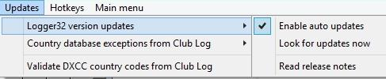

UPD_1

If no updates are available the following notice will be displayed:

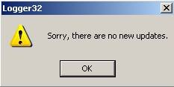

UPD_2

If new updates are available you will get a notice similar to the following.

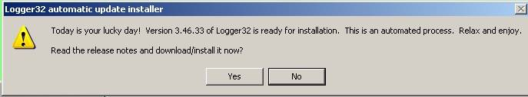

UPD_3

Select the <Yes> button and a dialog box similar to the following will appear. Read the release notice in the top pane. A check box offers the option to make backups prior to the update process

Note: If you select to save your backups to an Internet depository such as GOOGLE Drive you may have trouble completing the update download.You will need to allow time for the cloud system to synchronize the files before making another backup. If you have trouble with the backup process, it is suggested that you specify a path/file on your local drive and then upload this backup file to your Internet depository manually.
If you continue to experience problems making backups during Auto Update, it is suggested you initiate backups manually before starting the Auto Update process.

Note: The Release notes will be saved in the "\Release Notes\" folder in the Logger32 directory.

Select the <Install now> button and you can watch the update process in the lower pane. From this point on, it is a fully automated process. You will see the progress bar move to the right and then Logger32 will close and automatically re-open with the update installed.

Note: During the update the progress bar followed by a spinning "Pin wheel" will reflect activity.

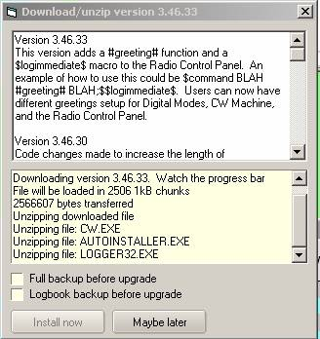

UPD_4

Note: Following are some suggestions for Window 7 & 8 users.

4.1 Failure of the Autoupdate Process

If you are experiencing difficulty with the Auto Update file down load, try some of the following:

  - Run as Administrator
  - Set Logger32.exe and Logger32autoinstaller.exe to run in compatibility mode:"Administrator: or "XP:
  - Set "Logger32.exe", Logger32autoinstaller.exe, and C:\Logger32 as exceptions in your Anti-virus.
  - Turn "UAC" OFF.

Specific process for Windows 8 users:

  - Close Logger32;

  - With Windows Explorer, navigate to the Logger32 directory. Locate the files Logger32.exe and Logger32autoinstaller.exe;

  - Right-click and choose properties;
  - Click on tab "compatibility";
  - Check: "Run this program as an administrator";
  - Click OK. Set both of the files listed in step 2 above.
  - Open Logger32 update.

4.1.1. If you are still having trouble with the autoupdate completing. There is a couple of things you can do to help yourself. Below is the sequence of events, which hopefully will assist you in determining what part of the process is failing.
Built into Logger32 is additional debugging capability which by default is disabled. Click VIEW and check the option ENABLE ERROR TRAPPING. If the error is generated within Logger32 (and not the auto installer), the exact line of code that fails is identified. Depending on you configuration, this option may also alert you of other setup problems you were unaware of. Who knows, maybe even more Logger32 bugs will be found.

4.1.2 Autoupdate process.

When Logger32 attempts to install an update, there is a review of the last few steps before it closes:

  - It looks in the \updatefiles folder for a newer version of QRX.EXE (the annoying pinwheel you see when updating). If there is a newer version, it replaces the existing one and deletes the copy from the \updates folder.

  - Starts QRX.EXE.

4.2 Additional Information on the Autoupdate Process

4.2.1 When Doing an Autoupdate

When doing an autoupdate, Logger32 accomplishes the following steps:

  - Copies the files from the \Logger32\updatefiles to the \Logger32\Rollback\ folder. The files will allow the user to roll back Logger32 to the previous version in case of trouble with the update;

  - Downloads the update file and unzips the files into a folder \Logger32\updatefiles; and

  - Closes Logger32 and copy the files from the \updatefiles\ to the \Logger32 folder and restarts Logger32.

Note: You can do these steps manually if the autoupdate fails.

There have been occasions where the PC configuration, security settings, AV and malware software have interrupted the process at a point where the \Logger32\updateFiles directory is empty. What you can do if the \Logger32\updateFiles directory is empty is find the file “zipfile.zip” The files needed are in \Logger32\updates\zipfiles.zip

We need to do two things:

  - Copy the update files to the \Logger32 directory; and

  - Copy the update files to the \Logger32\updateFiles folder so the next auto-update makes a valid \Logger32\Rollback folder.

Another option would be to delete the \updates folder in the \Logger32 folder. After deleting the \updates folder, be sure to close Windows Explorer. The Autoupdate should now run.

4.2.2 Rollback to Previous Version
If Logger32 does not work properly after an update and you want to rollback to the previous version then click Tools. Click Rollback to previous version. Check one of listed version you want to rollback. Click "Rollback" Automatic rollback run and copy files in corresponding Rollback folder in Logger32 folder. The list of options should now be limited to the most recent 10 versions.

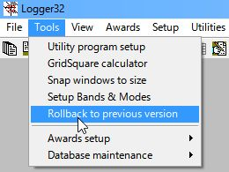

UPD_4A

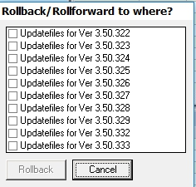

UPD_4AA

If Logger32 does not start at all after an update then find the file "Logger32Rollback.exe" in the Logger32 folder and run it..

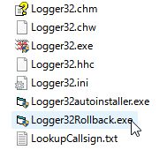

UPD_4B

Note: Logger32Rollback.exe should be always run as an administrator.

This process will only make one rollback. For example: If you were running version 3.50.250 and you auto-update to version 3.50.251. If you now have problems with version 3.50.251 you can rollback to 3.50.250. When you restart Logger32 3.50.250, you will be prompted that the 3.50.251 update is available. If you update for the second time to 3.50.251 you will not be able to rollback to 3.50.250 again.

4.2.3 If Things Work as Expected

If things work as expected, here's what actually happens. After the backup is completed (if the user so desires):

  - The file QRX.exe (the pinwheel) is copied from the \updatefiles folder to the Logger32 folder and is executed - The pinwheel starts. So, QRX.EXE must pass antivirus/malware/security checking;

  - The file “autoinstaller.exe” is copied from the \updatefiles folder to the Logger32 folder and is saved there as Logger32autoinstaller.exe (note the name change) and is executed - First thing it does is wait until Logger32 finishes shutting down, waits a few more seconds to be on the safe side, then copies all the files from the \updatefiles folder into the Logger32 folder and starts the new Logger32 version. So, autoinstaller.exe and Logger32autoinstaller.exe must pass antivirus/malware/security checking; and,

  - Eventually, when Logger32 is finished loading it stops QRX.exe. If the update fails, QRX.exe will stop itself after 15 seconds.

Note: When attempting an auto-update, notice that when the pinwheel appears, the PC beeps every 5 seconds? This beep tells you that the autoinstaller checked and there is still a copy of Logger32 (or the CW machine) running. The auto installer tries again to close Logger32 (or the CW Machine) and utility programs which use Logger32 external interface.
The autoinstaller looks at all the windows that are open on the PC. If any one of the windows has Logger32 in the title bar, it thinks that's Logger32 and tries to close it. This includes the Windows Explorer if it has the \Logger32\ folder open. If it finds Logger32 or the CW module and cannot close it, an error pane will advise the user.
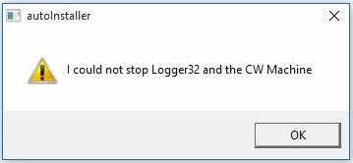

UPD_5

